**DATA MANIPULATION LANGUAGE**

**SQL INSERT UPDATE DELETE COMMANDS**

**mysql> create database ABCcompany;**

**Query OK, 1 row affected (0.16 sec)**

**mysql> use ABCcompany;**

**Database changed**

**mysql> show databases;**

**+--------------------+**

**| Database |**

**+--------------------+**

**| abccompany |**

**| companies |**

**| company |**

**| dbfirst |**

**| dbramya |**

**| information_schema |**

**| mysql |**

**| performance_schema |**

**| sys |**

**+--------------------+**

**9 rows in set (0.07 sec)**

**mysql> create table companystaffs(staffid int, staffname varchar(50), staffEmail varchar(50),Stafflocation varchar(50),staffphoneno int(50));**

**Query OK, 0 rows affected, 1 warning (0.33 sec)**

**mysql> select*from companystaffs;**

**Empty set (0.05 sec)**

**mysql> desc companystaffs;**

**+---------------+-------------+------+-----+---------+-------+**

**| Field | Type | Null | Key | Default | Extra |**

**+---------------+-------------+------+-----+---------+-------+**

**| staffid | int | YES | | NULL | |**

**| staffname | varchar(50) | YES | | NULL | |**

**| staffEmail | varchar(50) | YES | | NULL | |**

**| Stafflocation | varchar(50) | YES | | NULL | |**

**| staffphoneno | int | YES | | NULL | |**

**+---------------+-------------+------+-----+---------+-------+**

**5 rows in set (0.02 sec)**

**mysql> insert into companystaffs(staffid,staffname,staffEmail,stafflocation,staffphoneno)values(01,'Ramya S','Ramya1234@gmail.com','Chennai',88222867),(02,'vishali S','vishali1234@gmail.com','Chengalpet',76456780),(03,'hemasri S','hemasri1234@gmail.com','chennai',45589634),(04,'Rudhra M','Rudhra1234@gmail.com','chennai',67935463),(05,'kajol S','kajol1234@gmail.com','chennai',98654865),(06,'priya S','priya1234@gmail.com','chengalpet',66375834),(07,'Vijaya A','vijaya1234@gmail.com','chengalpet',25657869),(08,'selvakumar J','selvakumar1234@gmail.com','chennai',45689476),(09,'kannan G','kannan1234@gmail.com','chennai',45578796),(10,'Rajesh S','Rajesh1234@gmail.com','chengalpet',36758937);**

**Query OK, 10 rows affected (0.69 sec)**

**Records: 10 Duplicates: 0 Warnings: 0**

**mysql> select*from companystaffs;**

**+---------+--------------+--------------------------+---------------+--------------+**

**| staffid | staffname | staffEmail | Stafflocation | staffphoneno |**

**+---------+--------------+--------------------------+---------------+--------------+**

**| 1 | Ramya S | Ramya1234@gmail.com | Chennai | 88222867 |**

**| 2 | vishali S | vishali1234@gmail.com | Chengalpet | 76456780 |**

**| 3 | hemasri S | hemasri1234@gmail.com | chennai | 45589634 |**

**| 4 | Rudhra M | Rudhra1234@gmail.com | chennai | 67935463 |**

**| 5 | kajol S | kajol1234@gmail.com | chennai | 98654865 |**

**| 6 | priya S | priya1234@gmail.com | chengalpet | 66375834 |**

**| 7 | Vijaya A | vijaya1234@gmail.com | chengalpet | 25657869 |**

**| 8 | selvakumar J | selvakumar1234@gmail.com | chennai | 45689476 |**

**| 9 | kannan G | kannan1234@gmail.com | chennai | 45578796 |**

**| 10 | Rajesh S | Rajesh1234@gmail.com | chengalpet | 36758937 |**

**+---------+--------------+--------------------------+---------------+--------------+**

**10 rows in set (0.00 sec)**

**mysql> insert into companystaffs(staffid,staffname,staffEmail,stafflocation,staffphoneno)values(11,'Ramya S','Ramya1234@gmail.com','Chennai',88222867),(12,'vishali S','vishali1234@gmail.com','Chengalpet',76456780),(13,'hemasri S','hemasri1234@gmail.com','chennai',45589634),(14,'Rudhra M','Rudhra1234@gmail.com','chennai',67935463),(15,'kajol S','kajol1234@gmail.com','chennai',98654865),(16,'priya S','priya1234@gmail.com','chengalpet',66375834),(17,'Vijaya A','vijaya1234@gmail.com','chengalpet',25657869),(18,'selvakumar J','selvakumar1234@gmail.com','chennai',45689476),(19,'kannan G','kannan1234@gmail.com','chennai',45578796),(20,'Rajesh S','Rajesh1234@gmail.com','chengalpet',36758937);**

**Query OK, 10 rows affected (0.13 sec)**

**Records: 10 Duplicates: 0 Warnings: 0**

**mysql> select*from companystaffs;**

**+---------+--------------+--------------------------+---------------+--------------+**

**| staffid | staffname | staffEmail | Stafflocation | staffphoneno |**

**+---------+--------------+--------------------------+---------------+--------------+**

**| 1 | Ramya S | Ramya1234@gmail.com | Chennai | 88222867 |**

**| 2 | vishali S | vishali1234@gmail.com | Chengalpet | 76456780 |**

**| 3 | hemasri S | hemasri1234@gmail.com | chennai | 45589634 |**

**| 4 | Rudhra M | Rudhra1234@gmail.com | chennai | 67935463 |**

**| 5 | kajol S | kajol1234@gmail.com | chennai | 98654865 |**

**| 6 | priya S | priya1234@gmail.com | chengalpet | 66375834 |**

**| 7 | Vijaya A | vijaya1234@gmail.com | chengalpet | 25657869 |**

**| 8 | selvakumar J | selvakumar1234@gmail.com | chennai | 45689476 |**

**| 9 | kannan G | kannan1234@gmail.com | chennai | 45578796 |**

**| 10 | Rajesh S | Rajesh1234@gmail.com | chengalpet | 36758937 |**

**| 11 | Ramya S | Ramya1234@gmail.com | Chennai | 88222867 |**

**| 12 | vishali S | vishali1234@gmail.com | Chengalpet | 76456780 |**

**| 13 | hemasri S | hemasri1234@gmail.com | chennai | 45589634 |**

**| 14 | Rudhra M | Rudhra1234@gmail.com | chennai | 67935463 |**

**| 15 | kajol S | kajol1234@gmail.com | chennai | 98654865 |**

**| 16 | priya S | priya1234@gmail.com | chengalpet | 66375834 |**

**| 17 | Vijaya A | vijaya1234@gmail.com | chengalpet | 25657869 |**

**| 18 | selvakumar J | selvakumar1234@gmail.com | chennai | 45689476 |**

**| 19 | kannan G | kannan1234@gmail.com | chennai | 45578796 |**

**| 20 | Rajesh S | Rajesh1234@gmail.com | chengalpet | 36758937 |**

**+---------+--------------+--------------------------+---------------+--------------+**

**20 rows in set (0.00 sec)**

**mysql> update companystaffs set staffname='thivnesh' where eid =20;**

**ERROR 1054 (42S22): Unknown column 'eid' in 'where clause'**

**mysql> update companystaffs set staffname='thivnesh' where staffid =20;**

**Query OK, 1 row affected (0.19 sec)**

**Rows matched: 1 Changed: 1 Warnings: 0**

**mysql> select*from companystaffs;**

**+---------+--------------+--------------------------+---------------+--------------+**

**| staffid | staffname | staffEmail | Stafflocation | staffphoneno |**

**+---------+--------------+--------------------------+---------------+--------------+**

**| 1 | Ramya S | Ramya1234@gmail.com | Chennai | 88222867 |**

**| 2 | vishali S | vishali1234@gmail.com | Chengalpet | 76456780 |**

**| 3 | hemasri S | hemasri1234@gmail.com | chennai | 45589634 |**

**| 4 | Rudhra M | Rudhra1234@gmail.com | chennai | 67935463 |**

**| 5 | kajol S | kajol1234@gmail.com | chennai | 98654865 |**

**| 6 | priya S | priya1234@gmail.com | chengalpet | 66375834 |**

**| 7 | Vijaya A | vijaya1234@gmail.com | chengalpet | 25657869 |**

**| 8 | selvakumar J | selvakumar1234@gmail.com | chennai | 45689476 |**

**| 9 | kannan G | kannan1234@gmail.com | chennai | 45578796 |**

**| 10 | Rajesh S | Rajesh1234@gmail.com | chengalpet | 36758937 |**

**| 11 | Ramya S | Ramya1234@gmail.com | Chennai | 88222867 |**

**| 12 | vishali S | vishali1234@gmail.com | Chengalpet | 76456780 |**

**| 13 | hemasri S | hemasri1234@gmail.com | chennai | 45589634 |**

**| 14 | Rudhra M | Rudhra1234@gmail.com | chennai | 67935463 |**

**| 15 | kajol S | kajol1234@gmail.com | chennai | 98654865 |**

**| 16 | priya S | priya1234@gmail.com | chengalpet | 66375834 |**

**| 17 | Vijaya A | vijaya1234@gmail.com | chengalpet | 25657869 |**

**| 18 | selvakumar J | selvakumar1234@gmail.com | chennai | 45689476 |**

**| 19 | kannan G | kannan1234@gmail.com | chennai | 45578796 |**

**| 20 | thivnesh | Rajesh1234@gmail.com | chengalpet | 36758937 |**

**+---------+--------------+--------------------------+---------------+--------------+**

**20 rows in set (0.00 sec)**

**mysql> update companystaffs set staffphoneno=88888888 staffname='JAGAN K' where stafflocation='chennai';**

**ERROR 1064 (42000): You have an error in your SQL syntax; check the manual that corresponds to your MySQL server version for the right syntax to use near 'staffname='JAGAN K' where stafflocation='chennai'' at line 1**

**mysql> update companystaffs set staffphoneno=88888888, staffname='JAGAN K' where stafflocation='chennai';**

**Query OK, 12 rows affected (0.02 sec)**

**Rows matched: 12 Changed: 12 Warnings: 0**

**mysql> select*from companystaffs;**

**+---------+-----------+--------------------------+---------------+--------------+**

**| staffid | staffname | staffEmail | Stafflocation | staffphoneno |**

**+---------+-----------+--------------------------+---------------+--------------+**

**| 1 | JAGAN K | Ramya1234@gmail.com | Chennai | 88888888 |**

**| 2 | vishali S | vishali1234@gmail.com | Chengalpet | 76456780 |**

**| 3 | JAGAN K | hemasri1234@gmail.com | chennai | 88888888 |**

**| 4 | JAGAN K | Rudhra1234@gmail.com | chennai | 88888888 |**

**| 5 | JAGAN K | kajol1234@gmail.com | chennai | 88888888 |**

**| 6 | priya S | priya1234@gmail.com | chengalpet | 66375834 |**

**| 7 | Vijaya A | vijaya1234@gmail.com | chengalpet | 25657869 |**

**| 8 | JAGAN K | selvakumar1234@gmail.com | chennai | 88888888 |**

**| 9 | JAGAN K | kannan1234@gmail.com | chennai | 88888888 |**

**| 10 | Rajesh S | Rajesh1234@gmail.com | chengalpet | 36758937 |**

**| 11 | JAGAN K | Ramya1234@gmail.com | Chennai | 88888888 |**

**| 12 | vishali S | vishali1234@gmail.com | Chengalpet | 76456780 |**

**| 13 | JAGAN K | hemasri1234@gmail.com | chennai | 88888888 |**

**| 14 | JAGAN K | Rudhra1234@gmail.com | chennai | 88888888 |**

**| 15 | JAGAN K | kajol1234@gmail.com | chennai | 88888888 |**

**| 16 | priya S | priya1234@gmail.com | chengalpet | 66375834 |**

**| 17 | Vijaya A | vijaya1234@gmail.com | chengalpet | 25657869 |**

**| 18 | JAGAN K | selvakumar1234@gmail.com | chennai | 88888888 |**

**| 19 | JAGAN K | kannan1234@gmail.com | chennai | 88888888 |**

**| 20 | thivnesh | Rajesh1234@gmail.com | chengalpet | 36758937 |**

**+---------+-----------+--------------------------+---------------+--------------+**

**20 rows in set (0.00 sec)**

**mysql> delete from companystaffs where id = 10;**

**ERROR 1054 (42S22): Unknown column 'id' in 'where clause'**

**mysql> delete from companystaffs where staffid=10;**

**Query OK, 1 row affected (0.06 sec)**

**mysql> select*from companystaffs;**

**+---------+-----------+--------------------------+---------------+--------------+**

**| staffid | staffname | staffEmail | Stafflocation | staffphoneno |**

**+---------+-----------+--------------------------+---------------+--------------+**

**| 1 | JAGAN K | Ramya1234@gmail.com | Chennai | 88888888 |**

**| 2 | vishali S | vishali1234@gmail.com | Chengalpet | 76456780 |**

**| 3 | JAGAN K | hemasri1234@gmail.com | chennai | 88888888 |**

**| 4 | JAGAN K | Rudhra1234@gmail.com | chennai | 88888888 |**

**| 5 | JAGAN K | kajol1234@gmail.com | chennai | 88888888 |**

**| 6 | priya S | priya1234@gmail.com | chengalpet | 66375834 |**

**| 7 | Vijaya A | vijaya1234@gmail.com | chengalpet | 25657869 |**

**| 8 | JAGAN K | selvakumar1234@gmail.com | chennai | 88888888 |**

**| 9 | JAGAN K | kannan1234@gmail.com | chennai | 88888888 |**

**| 11 | JAGAN K | Ramya1234@gmail.com | Chennai | 88888888 |**

**| 12 | vishali S | vishali1234@gmail.com | Chengalpet | 76456780 |**

**| 13 | JAGAN K | hemasri1234@gmail.com | chennai | 88888888 |**

**| 14 | JAGAN K | Rudhra1234@gmail.com | chennai | 88888888 |**

**| 15 | JAGAN K | kajol1234@gmail.com | chennai | 88888888 |**

**| 16 | priya S | priya1234@gmail.com | chengalpet | 66375834 |**

**| 17 | Vijaya A | vijaya1234@gmail.com | chengalpet | 25657869 |**

**| 18 | JAGAN K | selvakumar1234@gmail.com | chennai | 88888888 |**

**| 19 | JAGAN K | kannan1234@gmail.com | chennai | 88888888 |**

**| 20 | thivnesh | Rajesh1234@gmail.com | chengalpet | 36758937 |**

**+---------+-----------+--------------------------+---------------+--------------+**

**19 rows in set (0.00 sec)**

**mysql> delete from companstaffs where stafflocation='chennai';**

**ERROR 1146 (42S02): Table 'abccompany.companstaffs' doesn't exist**

**mysql> delete from companystaffs where stafflocation='chennai';**

**Query OK, 12 rows affected (0.17 sec)**

**mysql> select*from companystaffs;**

**+---------+-----------+-----------------------+---------------+--------------+**

**| staffid | staffname | staffEmail | Stafflocation | staffphoneno |**

**+---------+-----------+-----------------------+---------------+--------------+**

**| 2 | vishali S | vishali1234@gmail.com | Chengalpet | 76456780 |**

**| 6 | priya S | priya1234@gmail.com | chengalpet | 66375834 |**

**| 7 | Vijaya A | vijaya1234@gmail.com | chengalpet | 25657869 |**

**| 12 | vishali S | vishali1234@gmail.com | Chengalpet | 76456780 |**

**| 16 | priya S | priya1234@gmail.com | chengalpet | 66375834 |**

**| 17 | Vijaya A | vijaya1234@gmail.com | chengalpet | 25657869 |**

**| 20 | thivnesh | Rajesh1234@gmail.com | chengalpet | 36758937 |**

**+---------+-----------+-----------------------+---------------+--------------+**

**7 rows in set (0.00 sec)**

**SCREENSHOT OF MY OUTPUT:**

**CREATE DATABASE & TABLE:**

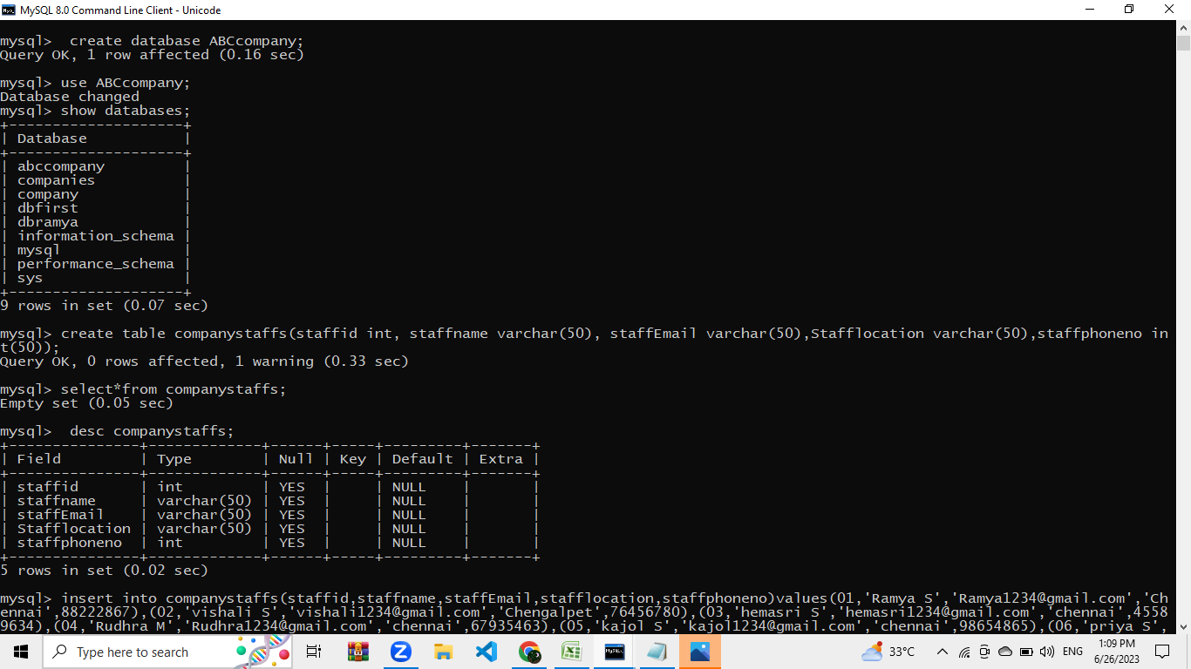

**INSERT COMMAND:** 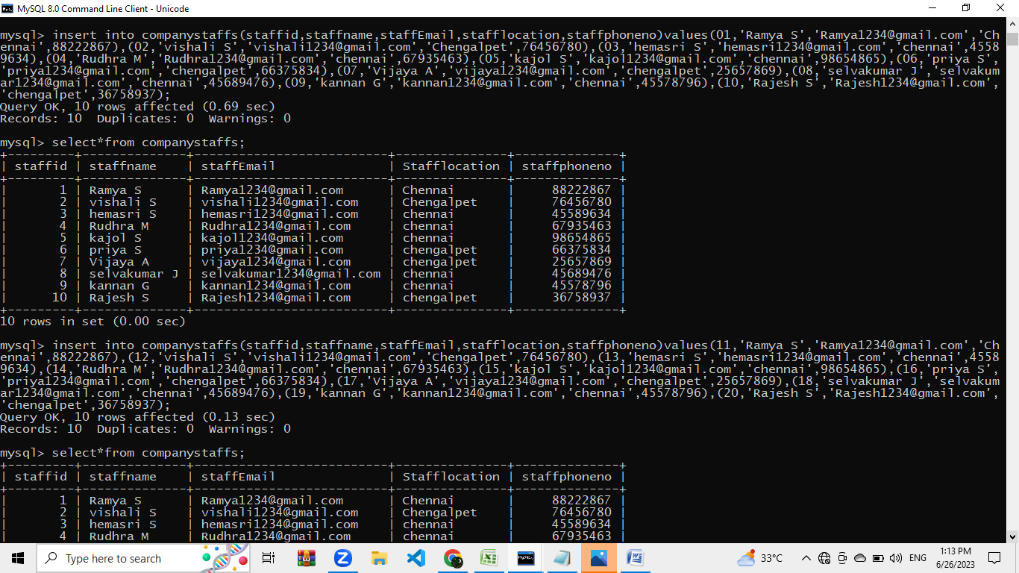

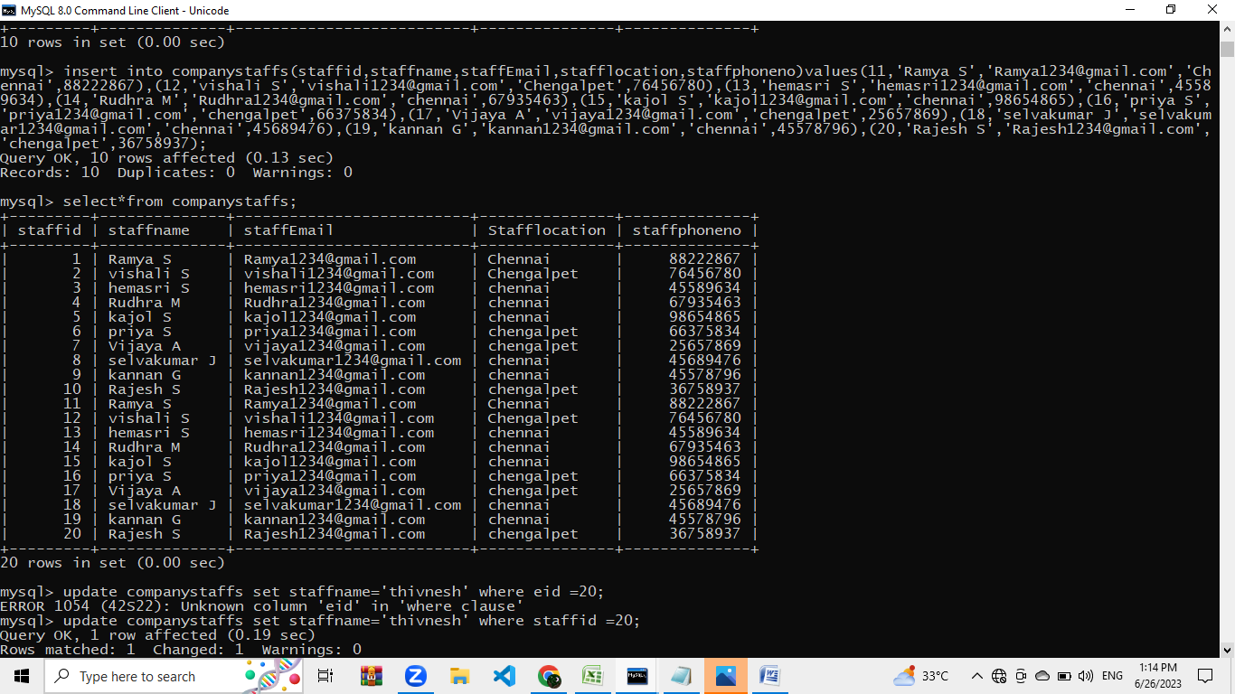

**UPDATE COMMAND:**

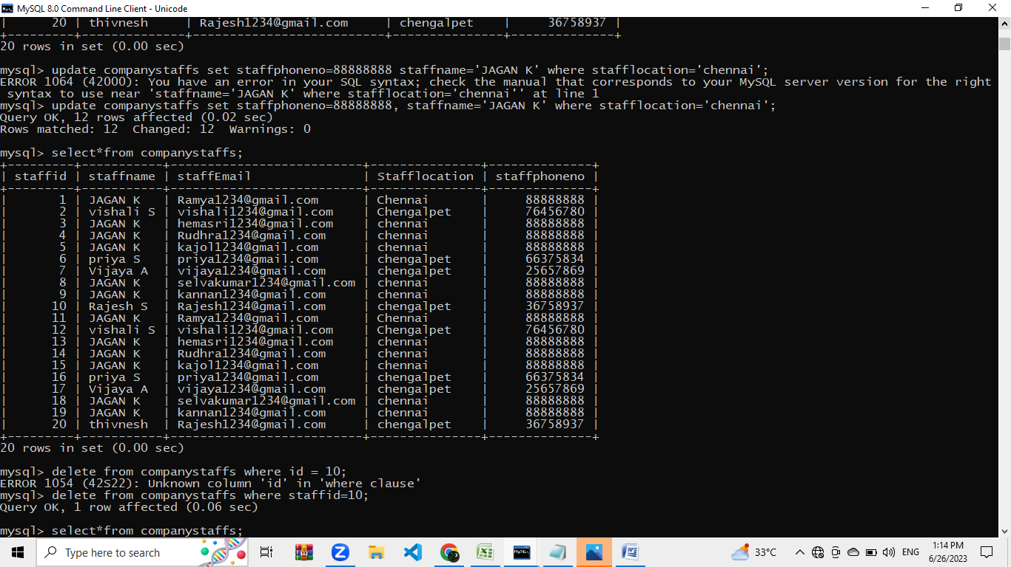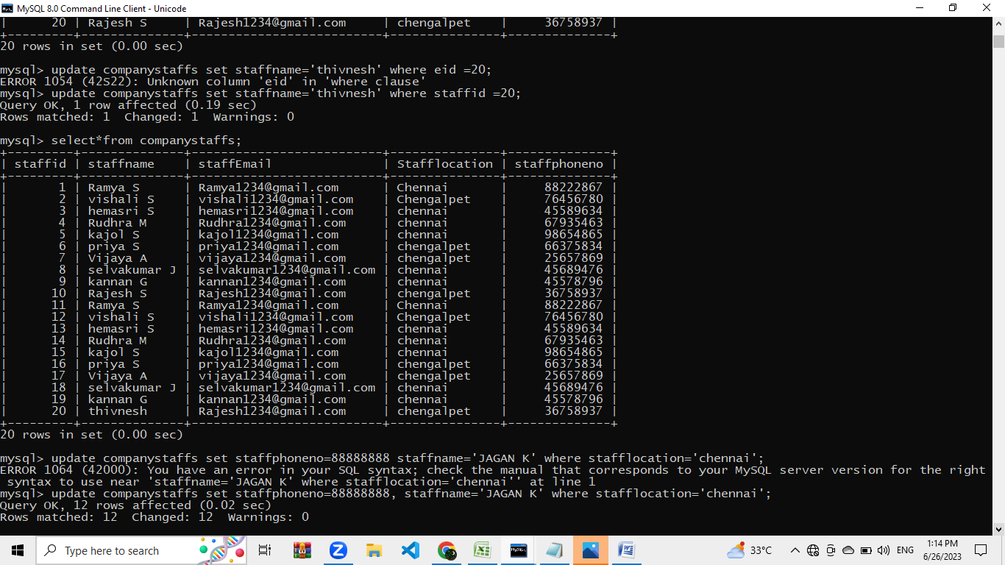

**DELETE COMMAND**

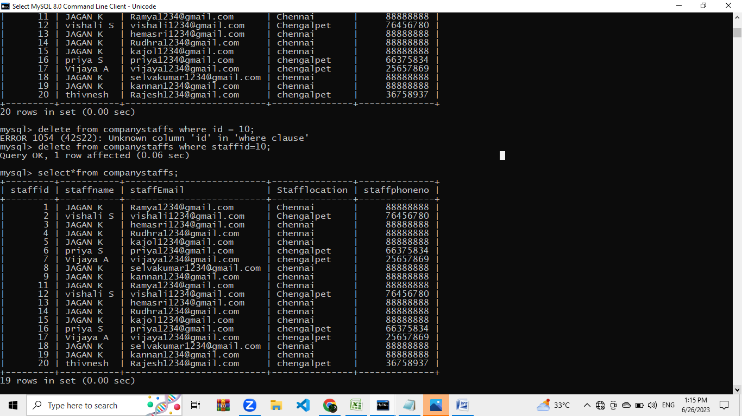

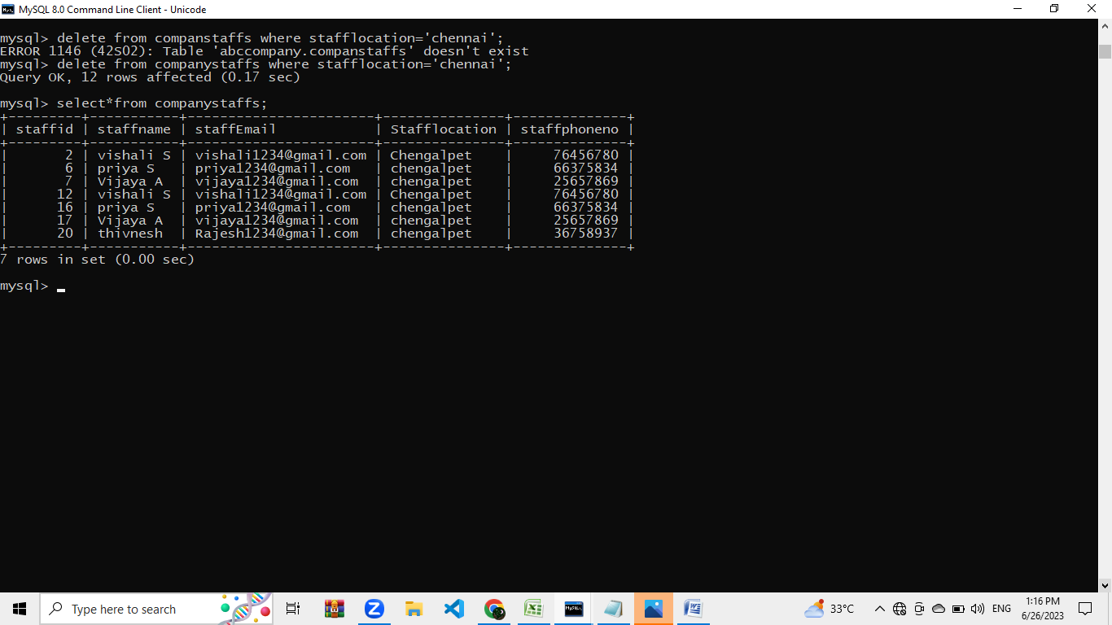

**------------------------------------FINISH----------------------------**